Tabitha Roemish

HW3: Suggestions

Program Description, Run Instructions and Output

Program Description:

This program provides an initial list of foods with the ability to add additional foods. A search function is provided which finds matches and near matches to select (which I take to meet the basic search [2] and additional suggestions [4] section of the assignment). These matches and additional near matches are ranked from highest match to lowest match and then displayed on the console. The output does not provide the rankings, but these are inserted into a BST and then printed in order of highest to lowest. Also, I entered a cut off of 50% and above match because I didn’t want to return items that were only vaguely similar, but this can at times limit the number of suggestions returned to less than three as stated in the instructions, however, I’m assuming that the search must have the capability to return multiple search suggestions and not that 3 suggestions are required for each search.

Note: I was not able to get this to compile in g++:

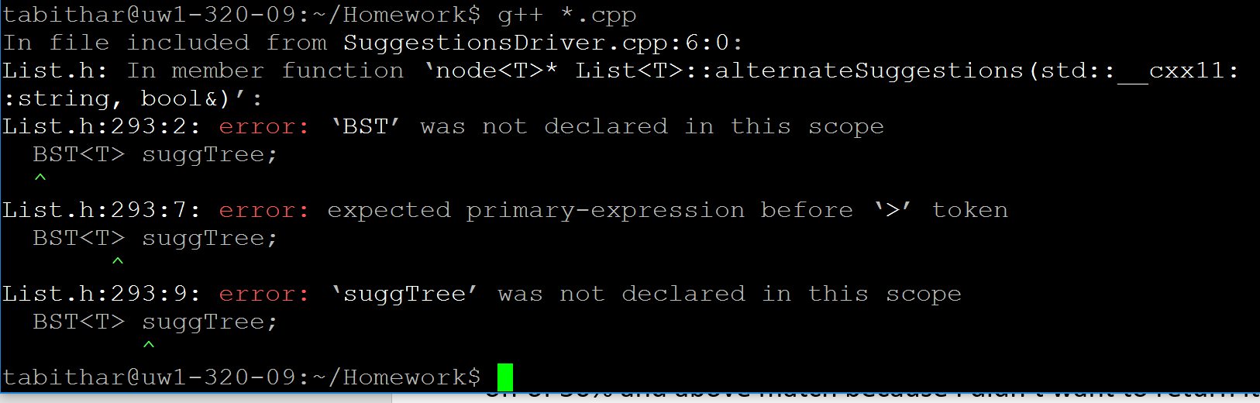

Run Instructions:

1. Three demonstrations are provided:
   1. A search that returns one result because nothing else was above a 40% match.
      1. You will need to enter the menu number to select the item or enter Q to quit search.
   2. A search that returns multiple results as search item generates several above 40% match.
      1. You will need to enter the menu number to select the item or enter Q to quit search.
   3. A search that returns no suggestions.
2. The next demonstrations require additional input.
   1. Demonstrate altering the list & searching
      1. The program will ask you if you would like to enter a food item.
         1. To enter a food item, enter Y and then you will need to enter a food name and an integer for calories.
      2. Next you will be asked if you want to search a food.
         1. To search enter Y and then enter the name to search.

Program Output: